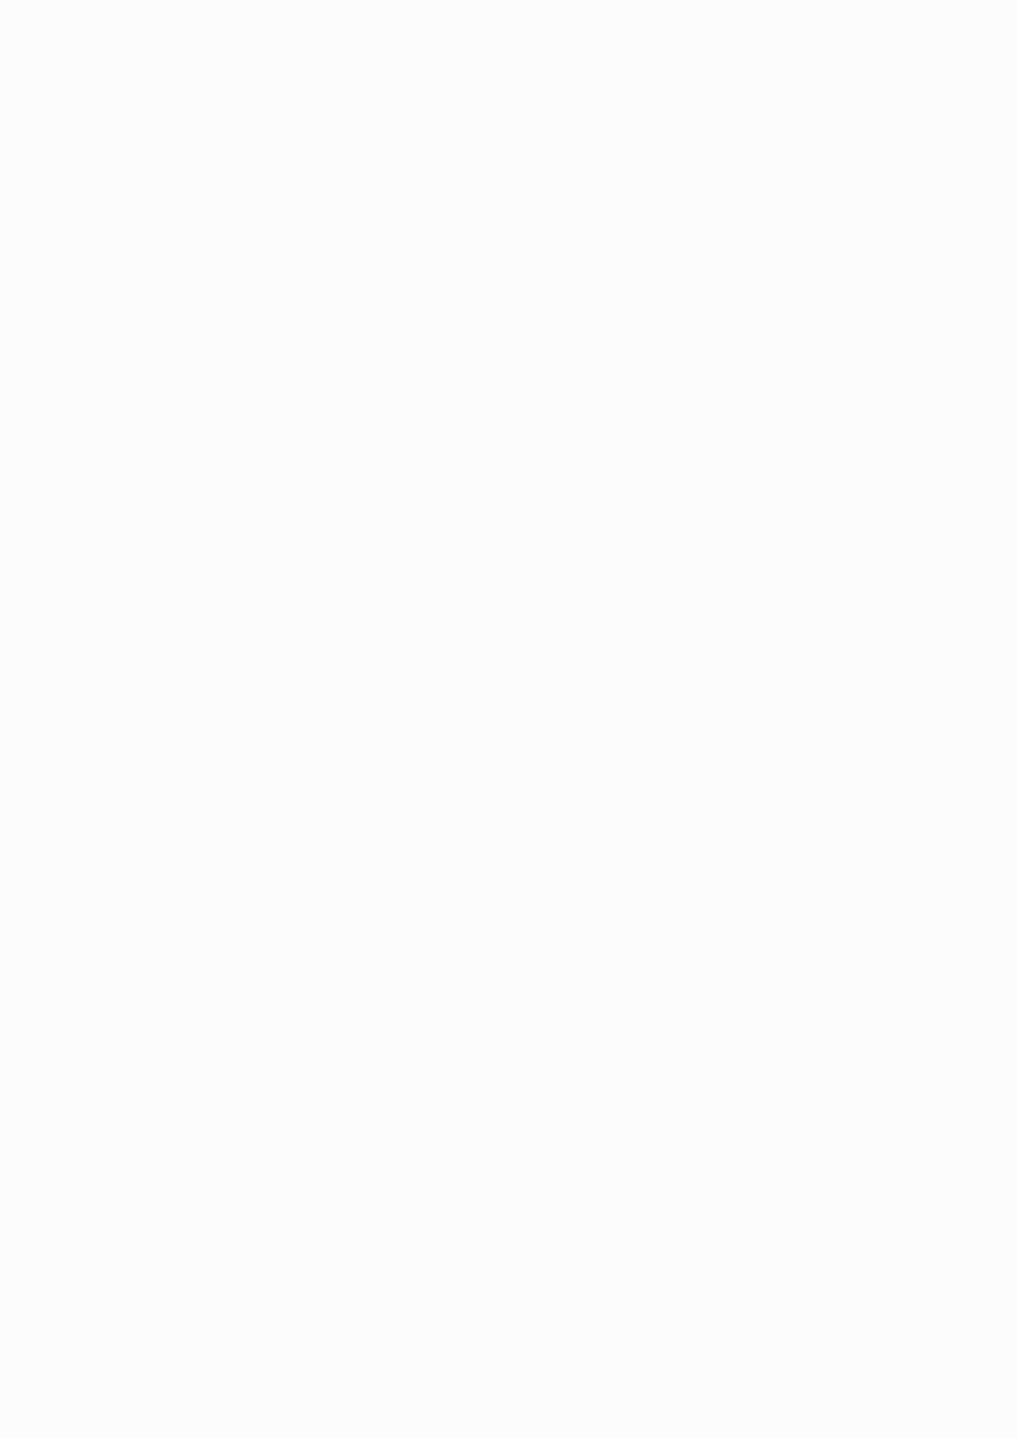
YOUR CHANCE TO BUY A PIECE OF COMMUNITY ART 🎨
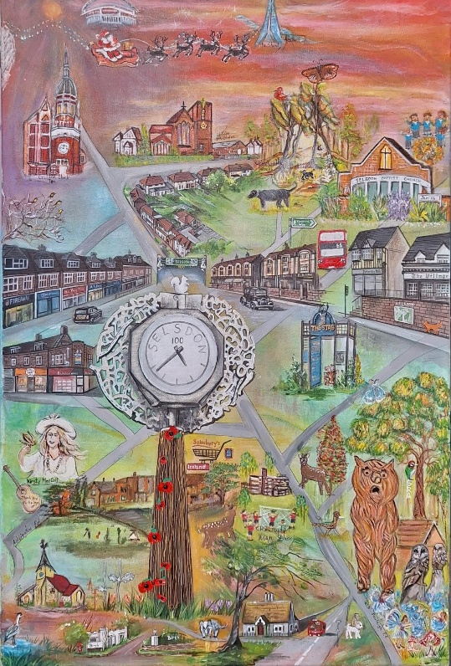
We are thrilled to announce a Blind Auction for our incredible, collaborative community painting, The Selsdon Centenary Community Painting.
This unique Artwork was created by many local hands and represents our shared spirit. It celebrates 100 years of the Selsdon Residents’ Association working for the Community.
Your Bid Submission:
Submit your highest offer in a sealed blank envelope with the following information inside:
- Name and/or Organisation
- Email Address
- Telephone number
- Your Bid (starts at £351)

Deadline: Friday 2nd October 2026, 10pm
Drop the envelope into The Golden Ark, 186 Addington Road, CR2 8LB
No none knows what others are bidding, with the highest bid winning the artwork.
All the envelopes will be put in a sealed box until Saturday 3rd October.
The funds raised will go to the main contributing artists with 30% going to two local Selsdon Charities.

The result will be announced at 3pm on Saturday 3rd October during the Selsdon Art Fair (18 local artists displaying their work) being held at St John the Divine Church Hall, Selsdon.

Don’t miss your chance to own this piece of local, social history, while supporting local charities at the same time.

Get your secret bids in now!
Maria Emmett

