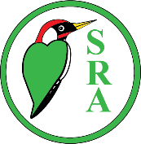

**SELSDON RESIDENTS’ ASSOCIATION**

**GAZETTE CHRISTMAS COVER COMPETITION**

for Selsdon’s primary and nursery school children

*Last time and date for entries to be received:*

**Saturday 16 November**



* A4 sized seasonal drawing or painting (nothing downloaded).
* Portrait or landscape but either leave a space for the Selsdon Gazette title, or have a full-page design that would allow the title to be printed on top of it.
* Put your name, address, school and date of birth on the back and then send it to the SRA via any of the committee addresses listed on page 2 of the Gazette or via KIBA, 119 Addington Road.