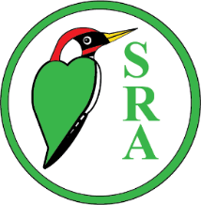
Selsdon Residents’ Association

GAZETTE CHRISTMAS COVER COMPETITION
For Selsdon’s primary and nursery children
Closing date for entries Saturday 15 November
All you have to do is make an A4 sized, suitably seasonal, drawing or painting. Put your name, address, school and date of birth on the back and then pop it in any of the SRA committee members’ addresses listed on page 2 of the Gazette or via KIBA, 119 Addington Road.
Your artwork can have any Christmas theme, but it has to be your own work, nothing downloaded.
The orientation can be portrait or landscape but please remember to leave a space for the Selsdon Gazette title or have a full page design that would allow the title to be printed over it and not spoil your picture.
The winning entry will be the colour cover for the December Gazette, whilst the runner up will appear on the back cover. There will be prizes for the winner and the runner up.
Remember you’ve got to be in it, to win it! 

