**Note to self** – send final proof to Councillor Helen Pollard and to [sally.drapeau@yahoo.ca](mailto:sally.drapeau@yahoo.ca) Send copy of last month’s Gazette to Des Donohoe. Xword from April 2016.

Crossword optional as usual

Front cover image credit for June

Pyramidal Orchids by Lyn Ellard. Although this photograph was taken in 2015, these flowers are a regular feature in the fields of Selsdon Wood and seen on the June walk each year.

Front cover image supplied – **Fab Four**

**Change to p 2 listings of SRA members - at the bottom of the page please add:**

Full details of the roads falling within each of the new Selsdon wards can be found on the Home page of the SARA website <https://selsdon-residents.co.uk>

**Adverts:**

**OUT:**

* **Jubilee Running** - p13 of May issue
* **FSW Walks of Discovery** - p62 of May issue

**IN**

* **S**

**LOCATION:**

* **Selsdon & District Funerals** – please keep on P1

**Editor’s Note**

Welcome to the June 2019 issue of the Gazette.

We start with an important notice about the Big Selsdon Litter Pick. This is an issue after my own heart so do please inform the organisers of litter blackspots to address on the day.

Lots of history this month. Des remembers what it was like going shopping in Selsdon when he was a lad and this is followed by a response from Martyn Stagg to Phil Munton’s article in the March issue about the Ingham Road bombing. Phil himself provides another instalment up with an account of his time at Selsdon Primary School. This month’s final fascinating slice of local history comes in a few letters in response to the request for information about the car belonging to first owner of the Selsdon Park Hotel published in the March issue. Several people have contacted me to tell me that the owner was Mr Sanderson and providing links to a number of fascinating online sources.

Jessica Blake tells us about her wonderful day and we then have the second instalment in Bill Gale’s letters from America.

In the regular letters section the saga of the Selsdon Park Hotel continues - with further information about their dogs and the painting of the Labradors that was in the entrance hall.

Regards,

Heather

**🙞 Submissions for the JULY 2019 edition should be with the editor no later than 20th JUNE. 🙝**

**~~**

**SRA NEWS ‘n’ VIEWS**

I‘m sorry to have to start this month’s article with a messy topic - dog poo in the woods and other open spaces. It seems that people are getting lazier about dealing with their pets’ poo in public places these days. The SRA and Friends of all open spaces get complaints about this but we realise there is no easy answer as long as some people continue to be inconsiderate.

FSW have been in discussion with the Council about the provision of additional ’poo’ bins in the wood in the hope this might help ease the problem there. These would have financial implications (purchasing+siting+routine emptying) which the council budget does not generally allow for. However, FSW have agreed to finance the siting of up to three extra bins (@ £600) as long as the council provide them and empty them regularly. This is not perhaps what FSW originally intended to spend their funds on but, in the hope it makes for a cleaner walk, we consider it money well spent.

If you walk a dog in a public place, please remember any litter bin (not just the specific ‘poo’ bins) can be used for bagged ‘do-ings’.

Another way you can help is to keep your dog on a lead if first arriving via the car park: dogs might be ‘desperate’ and run off to relieve themselves before you realise where they have ‘gone’. Then you have to hunt to find the pile to bag it. Please do not think it is o.k. to leave it in the field as it is not pleasant for people with children playing there to find mess on their shoes or to have to search for a clean patch of grass to sit on. Dogs can be kept on a lead and still get exercise – children can’t! Also, please remember that dogs should always be on a lead or obedient dogs completely under their owner’s control when near people as many are afraid of even the smallest or kindest dog or feel uneasy or unsafe if a dog is running around or barking or jumping up at them, even if the dog walker considers ‘they are just being friendly’.

One last point re: poo – just a reminder that bags with poo in are not suitable tree decorations and neither should they be disposed of in the undergrowth. If you really cannot face carrying the poo bag with you, then please do not bag the poo; instead, flick it well off the path into the undergrowth so it will not get trodden on by walkers and will rot away in due course. This is deemed acceptable practice in suitable areas.

SRA Subs envelope collection points are listed in this Gazette and will be in the July edition too so please can I ask you to let us know if you wish to offer your letter box as a new point or if you want your address removed from the list. I hope I have already deleted all those who gave me notice during the year – I am sorry if I have forgotten to take any address off. If you have arrived in Selsdon in the past year, apologies if the person who lived at the address before you did not tell us they were moving away or forgot to explain to you about these envelopes suddenly appearing, mostly during the summer months! If you do get them, please pass them on to any committee member (addresses inside the front cover) or leave at the Selsdon Centre, in Sainsburys’ foyer: it is safe to use the Centre’s letter box out of office hours.

Bus route changes – You will no doubt recall there was a plan and public consultation by TfL to re-route some of Croydon’s buses. At the time of writing, we only know that the 75 will continue to pass through West Croydon to Fairfield - in response to public pressure. We await news on the other potential changes in due course from TfL - and from the East Surrey Transport Committee who work on our behalf in such consultations.

Christmas Lights – Thanks to the volunteers at the AGM, we now have a full SRA committee so we are again able to make plans for the Christmas Lights – yes, already, so please put the date 22nd November in your diary! A new lighting display has been ordered (even better and brighter than before, we hope!), Greenvale School have offered to make decorations for the trees on the Triangle (but you can always make some more please, as I suggested in an earlier News’n’Views), and the new catenary wires will be fitted in time for the lights. As has already been reported, this is now a significant on-going additional expense for the SRA because, as well as new wires having to be bought this year and possibly renewed more often than before , the wires now have to be formally checked at regular intervals to satisfy H&S and insurers. Nevertheless, we feel we should try to continue with the lights tradition here for as long as possible, particularly as we had the especially strong lamp posts fitted for them. With the support of some of the traders, a lot of the residents who send their donations in their subscription envelope or via the various collections we hold during the lights season, and the Selsdon councillors’ community funding, and as long as there is no other major drain on our finances (such has a large scale planning operation such as we had when fighting Tesco and then Sainsburys before they arrived), we should have sufficient funds for at least about 7 more years. I think by then I will have organised them for long enough – so do start thinking if/ when you would like to take over! I’m always open to offers!

Following on from our initial trial of decorating the Triangle last Christmas, which seemed to work well, we made enquiries about adding a string of coloured lights to the trees around the edges. Whilst not being as expensive as we thought they might be, in the end, we felt it was imprudent to add to the overall cost as obviously there is always a rise in the costs anyway when we take out the next contract even if only to maintain the same quality of display. However, we understand we could, of course, easily add these lights as an extra, even at short notice, if some additional kind donors or sponsors come forward to pay specifically for these. Do any of you feel extra generous or perhaps we should invest in a lottery ticket or two?

Selsdon Community Fun Picnic afternoon – The other main activity in recent years for the SRA committee has been to encourage the residents to come to this event. Those who did come said they had fun and enjoyed meeting other people from the area – but so few came that we do wonder whether it was worth the effort. We are trying a different format this year: we are combining the SRA event with the FSW Open Day on Sunday 8th September. The Selsdon Rotary Club has agreed to give its support and help run the fun races. The Scouts will also have other activities and games as usual as well as their regular FSW Open Day refreshment stall – so no need to bring a picnic if the weather doesn’t look appropriate for picnic hampers, wine and blankets on the grass! We are hoping to have a climbing wall as a new attraction but we cannot get confirmation of that until late June at the earliest for reasons too complicated to explain in the space available here! Look out instead for news on posters and on the websites* in due course.

The FSW invites local charities, crafts people and hobbyists and any others who would like to have a stall to display items of interest or run an ‘activity’ of some sort. We would like to have some new faces this year – maybe a children’s entertainer or magician, interesting pets etc? Would you like to have a stall or know someone who might? They don’t have to live in Selsdon to take part. Please contact me via the FSW email address and I will send more details to anyone who is interested: for the stall to be included in the publicity for the day in the July Gazette (there is no August issue and the September one is unlikely to be delivered by the Open Day) I need to know by 19th June at the latest. We hope to see every Selsdon resident there anyway – why not come to the community picnic instead of having a street party this year?

***Linda Morris, Vice Chairman, SRA and Secretary, FSW***

SRA - website: <https://selsdon-residents.co.uk>

Selsdon Gazette - email: [SelsdonGazette@hotmail.co.uk](mailto:SelsdonGazette@hotmail.co.uk)

FSW - website: <http://www.friendsofselsdonwood.co.uk> email: [selsdonwood@gmail.com](mailto:selsdonwood@gmail.com) FoLW - website: <http://www.folw.co.uk>

**~~**

**Farewell to the Tudor Library Patel family**

from the SRA on behalf of all of Selsdon

I expect most of you will have seen the notice that appeared in the newsagent’s window in early May – that Mr and Mrs Patel are retiring after 35 years of early mornings and service to the Selsdon community. We were aware they had wanted to go for some time but that they had had trouble finding the ‘right’ buyer. They believe the new owners, Mr and Mrs Shah, fit the bill. Please let’s make them welcome so they stay for a good few years too. Their shop is truly the hub of Selsdon now (perhaps apart from Wetherspoons and the newer craft beer venue!), especially since the post office has moved there and become so useful to us all.

We certainly need these traditional outlets to help keep our shopping area alive. We thank Mr and Mrs Patel for taking on the post office and trust that you will all continue to use it and the paper shop aspects of the business so that Mr and Mrs Shah will have a happy and profitable time here too.

All good wishes to the Patels in their retirement – may they enjoy many a long lie-in!

**~~**

**COUNCILLORS’ NOTES**

**PLANNING PROTESTS**

On 1st April a huge crowd of residents from across Croydon flocked to the Town Hall to protest against the planning decisions being made by the Council Planning Committee. That evening the Council was being asked to approve the Suburban Design Guide Supplementary Planning Document (SPD2), the planning document that will form part of the guidelines to be applied when decisions are made about future planning applications. The main theme of the document is to allow more intense developments to be built in areas like Selsdon. Sadly, the protests about SPD2 fell on deaf ears and the new Planning Document was nodded through by the Labour councillors.

Protesters recognised the necessity of building more homes in Croydon but felt there should be more development on brownfield sites and greater input from local residents about where the homes should be built. In the meeting Conservative councillors proposed a motion to set up Area Planning Committees that would allow this to happen. This approach has worked well in other areas and is more sensitive to the needs of each locality. Regrettably, the motion was voted down by the Labour Councillors, to the dismay of the crowd who were watching the meeting.

So what does this mean for Selsdon?

It means that a detached bungalow in a residential street could be replaced with a block of flats. It means that residents will be encouraged to submit joint applications to convert 2-3 plots of land with detached houses, into mini estates with buildings on the street front and in the garden. It means that if your neighbour proposes to replace their house with a much bigger building that overlooks your home and garden, there will be very little we can do to stop it.

As your local councillors we will continue to resist insensitive development in Selsdon, but the decisions made at the meeting on 1st April have made this much more difficult.

**CAR PARK CHARGES**

Proposals have been put forward to change parking charges to reflect the impact a vehicle has on the environment. The cost of parking will increase, with every vehicle other than fully electric-only vehicles paying 30% more, and anyone wanting to pay cash at a parking meter or having a vehicle older than 2001 paying 30% more as well. Plug-in hybrids will pay the same as most petrol cars and all but the most polluting gas guzzlers.

It is good to encourage people to be more environmentally friendly but it is feared this policy will be a tax that penalises the elderly and low income residents who can't afford to buy a new vehicle. It could also hit small businesses that rely on vehicles to trade.

Any change that affects the cost of parking will hit Croydon’s retail trade and other local businesses, so we have to hope that if the change goes ahead it does not affect the local economy, or our most vulnerable residents.

**SELSDON LIBRARY**

Councillors recently had a briefing from the Council about the refurbishment of Selsdon Library. During the summer the library will be closed in order to install a new IT network which will improve wifi, refresh the ICT hardware, install new furniture and lighting, and prepare for extended opening hours.

Selsdon Library will be a pilot for extended opening hours which will be put in place without additional staffing. Residents will be able to access the Library using a library card and PIN for some hours outside the normal library opening times. They will be able to access computers and use self-service kiosks for borrowing and returning books. CCTV will be in place to monitor this.

The enhancements to the Library are welcomed but there will be a period when the library will be closed to allow the works to take place. The closure will take place from 1st June to 2nd August 2019. Whilst the technology for the out-of-hours access will be installed in the summer, it won’t go live until the autumn.

**WHERE’S WESTFIELD?**

There is increasing concern about the regeneration of the centre of Croydon. The Westfield development has stalled and there is no date for the start of the project. After many delays, the project was due to start this year with a view to opening in 2023, but in February it was announced that there would be a further delay and it is not known when the work will start.

The development has twice been given planning permission and all the necessary compulsory purchase orders have been agreed, but the developers need more time to put together a workable scheme. The rapidly changing retail landscape has presented many challenges for this project.

The recent announcement of the closure of some Debenhams stores has made the situation even more worrying. The issue has been raised with the Mayor of London and the government and it is hoped the development will go ahead soon.

**FAIRFIELD HALLS**

In the April Gazette we gave an update on Fairfield Halls. The project is running 18 months behind schedule and we had just found out that the cost of the refurbishment had escalated from £30m to £41m. Questions were asked about the additional £11m cost and it appears that £4m is due to additional costs for asbestos removal.

This raises a number of questions.

Firstly, what is the other £7m for? Cllr Pollard has asked for clarification on this.

Secondly, how can the asbestos removal have been so badly estimated at the outset? It is well known that buildings of this era had asbestos, and an asbestos survey was carried out before the project started.

Thirdly, the project is being managed by the Council’s own subsidiary Brick by Brick, a company set up a few years ago and it has yet to complete a project of any size. Is it right that an organisation with so little experience was given a project of this magnitude?

We all want to see Fairfield Halls reopen but we don’t want to pay for a poorly managed project. We will keep a close eye on the refurbishment project and report back with any further information.

**Meet Your Councillors**

The Selsdon Team of Councillors will be holding surgeries in the Selsdon Centre (next to Sainsbury’s) on the first Saturday of the month from 10am – 11.15am (except August). If you have any issues you wish to discuss with your councillor please come to the surgery or get in touch by email:

[Helen.pollard@croydon.gov.uk](mailto:Helen.pollard@croydon.gov.uk)

[Robert.ward@croydon.gov.uk](mailto:Robert.ward@croydon.gov.uk)

[Stuart.millson@croydon.gov.uk](mailto:Stuart.millson@croydon.gov.uk)

[Andy.stranack@croydon.gov.uk](mailto:Andy.stranack@croydon.gov.uk)

**PLANNING APPLICATIONS April 2019**

19/01571/HSE – 158 Croham Valley Road, South Croydon, CR2 7RA - Alterations, erection of a single storey rear/side extension

19/01167/FUL – 101 Croham Valley Road, South Croydon, CR2 7JH - Erection of a single storey rear extension and a first floor side extension

19/01498/FUL – 5 Kingsway Avenue, South Croydon, CR2 8NF - Erection of attached 2 bed dwelling, provision of parking, cycle and refuse storage, associated alterations

19/01274/FUL – 2 Foxearth Road, South Croydon, CR2 8ED - Erection of two bedroom attached house

19/01138/FUL – 14 Brent Road, South Croydon, CR2 7NR - Proposed single storey front, side and rear extension; and first floor side extension

**~~**

**POLICE BOX**

**The Selsdon Vale & Forestdale Local Policing Team (LPT) comprises:**

**Sergeant Paul Harrison, PC Colin Mayes**, **PC James McCarthy**

All hold the position of DWO - Dedicated Ward Officer.

**The Selsdon and Addington Village LPT comprises:**

**PC Carl Gates, PC Barry Swift, PCSO Tina Nash, PS Bob Batchelor**

**Contact details:**

While 999 (emergency) and 101 (non-urgent) numbers will always reach the police, if you want to contact them on local area matters of wider concern you can use:

**Selsdon Vale & Forestdale LPT** or **Selsdon and Addington Village LPT**

**Addington Police Station, Addington Village Road, CROYDON CR05AQ**

Tel - **0208 721 2464**

[sntzd-.selsdonandaddingtonvillage@met.police.uk](mailto:sntzd-.selsdonandaddingtonvillage@met.police.uk)

[sntzd-.selsdonvale&forestdale@met.police.uk](mailto:sntzd-.selsdonvale&forestdale@met.police.uk)

(note that this unusual format - with a dash and dot after sntzd - is correct)

**~~**

Many readers of the Selsdon Gazette may have noticed that the streets of Selsdon are not always as clean or tidy as they should be. Litter is not only an eyesore, but can also be a danger to people, pets and wildlife.

A number of people from Churches Together in Selsdon and Addington are planning to spend the morning of Saturday 15th June out and about in Selsdon, picking up litter. As far as possible the litter will be sorted so that recyclable materials can be properly processed.

If you are aware of particular litter spots in Selsdon, the organisers will be very grateful if you could pass on the details to them before the end of May, so that they can plan for the volunteers to cover the areas which are most in need of having litter removed.

Please contact Selsdon Baptist Church office by 31st May with information as to where litter needs removing. The office number is 020 8651 4308; email [office@selsdonbaptist.org.uk](mailto:office@selsdonbaptist.org.uk). Thank you.

***Linda Wright***

**~~**

**GOING TO THE SHOPS – SELSDON IN THE 40S AND 50S**

*(All photos taken Nov 2018)*

The green fields of Selsdon Farm were transformed into an extensive housing estate during the mid 1920s to the late 1930s. My parents bought a new semi-detached house in Abbey Rd in about 1935 which then cost £695. The ongoing house-building ceased as a result of World War II.

As one would expect, there was also a planned development of a “high street” of shops. This of course was along the Addington Road. However this plan was also upset by the war, with not much more than about two thirds of the shops being completed and trading during most of the 1940s.

The whole block shown below had the flats above completed, but all 9 shop units at ground level were empty and boarded up until sometime after the war ended.

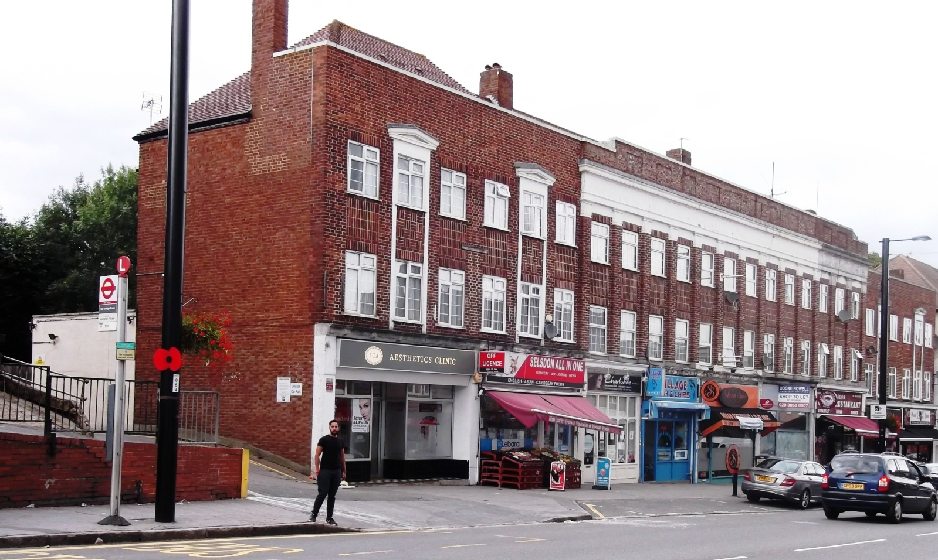

At the other end of the shopping centre, starting at Selsdon Garage, there were three shops; a wool shop, Tudor Library which is still there, and lastly, Monty’s a baker’s shop.

I hope that the two photos below will help to illustrate the changes, pre- and post-war.  
You can see in the left-hand photo that there is a “newly” built block of shops and flats up as far as the drive-through entrance. Originally this was only a single storey row of open but empty shop units. There were no flats over them; these were a circa1970s add-on. To better illustrate the halfway stage between what I was seeing during the war in the 1940s, and what you will see today, is this photograph at <https://www.francisfrith.com/selsdon/selsdon-addington-road-c1965_s613041> . This shows the new post-war shops, but before the flats were built on top of them much later.

In the right hand photo below, starting from over the drive-through entrance, again there were 3 or 4 empty shop units, but these did have flats over.

The differences in design and construction materials of these flats provide a clear indication of the different phases of development, pre- and post-war. I should also add that the present-day shops are not those that first occupied the shop units. The many different occupiers over the years would need a whole chapter to record!

|  |  |
| --- | --- |
| DSCF1612 - Copy.JPG | DSCF1611 - Copy.JPG |
| New shops with added flats over (at left) | Pre-war flats with new shops below |

Finally, from today’s Iceland to Barclays Bank, where there is a now a block containing some six different shops, there was in my young days just an open area of waste land with an Air Raid Wardens post on it. So in total, over 20 fewer shops than now.

Today we are used to supermarkets. The nearest that Selsdon had to one in the 1940s, was the South Suburban Co-operative Society shops. I say shops because there were two, next to each other - a grocery shop and a butcher. These were in the premises now occupied by Nationwide (the butcher’s), and the pub, Sir Julian Huxley, which provided a large, double fronted grocery shop. The old shop on the corner was an off-licence.

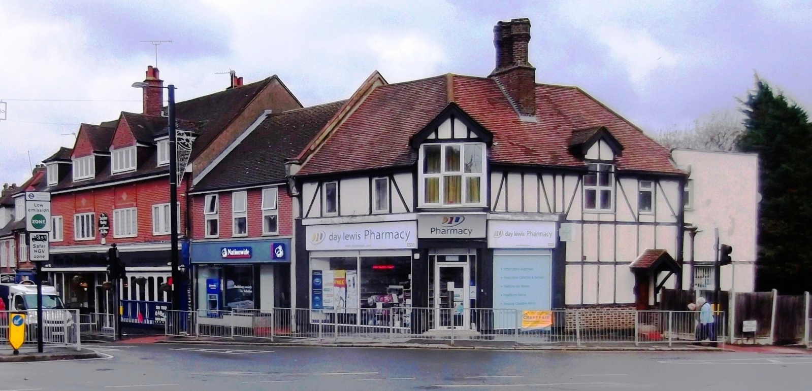

Shopping choice was further restricted by rationing regulations. You were required to nominate the shops at which you would use your ration coupons, when purchasing many goods. So you would have to nominate a butcher for meat products, a grocery shop for tinned fruit/meat, dried items such as prunes, peas, legumes, etc. My mum nominated the Co-op for both meat and groceries, but our next door neighbour for example, used Ockleford’s, a local butcher who had his own pig farm in Ashen Vale, and Cave Austin’s for groceries.

Some other important staples were not rationed, but subject to regular supply shortages. These included bread products (Monty’s Bakery), fresh and hence seasonal fruit and veg (Nash’s and Cowley Nurseries), fresh fish and fish and chips. I cannot remember the original owner of the fish shop, but later it was Sand’s or Sandy’s whose son I knew at Selsdon Primary. There was a good range of shops in Selsdon - virtually everything that was normally needed - only lacking a candlestick maker! It also helped that most of the shop owners lived in Selsdon. No doubt this also helped, as was rumoured, in a little bit of black market dealings with favoured customers!

Food rationing covered a very wide range of products, too many to detail here, but one last item to mention is milk; 3 pints a week for adults and children under 5, and 3.5 pints for children under 18. Additionally, each consumer (i.e. both children and adults) could get one tin of “Home Semi-skimmed Dried Milk” every 8 weeks. This was equivalent to 8 pints of milk. (Children pre-school age got full cream milk from the Children’s Welfare Centre at the Baptist Church Hall). I mention milk because something that you do not now see today, in the high street, is a milk shop. There were two in Selsdon!

|  |  |
| --- | --- |
| United Dairy.JPG | old Express D.JPG |
| Kiba was originally United Dairies shop. Red was their signage colour | Kebab shop behind bus shelter was originally the blue Express Dairy shop |

You may wonder why there were two dairy shops in Selsdon when the milk was delivered to our front doors, by the local milkman on his horse drawn milk float. I still wonder!

I did go with my Mum to these dairy shops on a few rare occasions, but to buy what I have no idea! My best guess would be to buy cheese. Before the war 70% of cheese was imported but this supply was virtually cut off during the war. So being in very short supply a “Government Cheddar Cheese**”** was introduced, presumably a mixture of whatever was available at any time.But not very often available for us to eat!

Shopping was virtually a daily chore. As was the queuing when you got to each shop for the meagre rations that you were allowed to buy – if they had it in stock! This resulted in a help thy neighbour system. In those days, long before the internet and social media, messages were by word of mouth. A neighbour knocking the door to say, “They’ve got sausages at Ockleford’s, get down there quick!” And off you went, immediately. Even then, often when you got to the shop it had sold out.

Finally to end this introduction to wartime shopping, the poor old mums had to carry all the heavy shopping home in baskets or shopping bags, one in each hand! And I can assure you, a basket full of muddy potatoes weighs a ton – or so it seemed on the long walk home.

After the war finished, plus a couple or more years when petrol rationing finished, a business was started by an entrepreneur in Thornton Heath. He (or they) bought a couple of war surplus army lorries and went around knocking on doors. This new business was called “The Direct Potato Supply Company”. A half-hundredweight bag of potatoes delivered to your door once a fortnight. It went down a bomb!

***Des Donohoe***

***Please include photos if space allows***

**~~**

**MORE ABOUT THE INGHAM ROAD BOMBING**

Phil Munton’s article in the March issue was interesting as I used to live in Ingham Road, but it contains a number of errors. In the photograph showing the front of the houses number 21 (later changed to 41) is on the left where the front is still standing and number 22 (42) is complete destroyed. The bomb came down on the site of 23/24 (43/44). This was an empty plot because war had broken out before they could be built. Norman Godfrey who lived at 26 (46) kept chickens and had his chicken run on this plot. He and his wife were away when the bomb came down. They returned to find their chickens wandering about and in the trees. He never told me if his house or that at 25 (45) were damaged in the blast but judging from what happened to Phil’s parents’ house I imagine there would have been some damage.

In December 1952 my parents, who had been living with my maternal grandparents, moved into their newly built house at 24(44) Ingham Road with my brother (who was 3½) and me (aged six months). I remember my father talking to someone about the problems they had when they moved into the house and referring to the huge heap of building rubble including a complete brick arch which had to be removed. I don’t think he ever knew where it all came from, but I am guessing that builders who rebuilt the damaged houses took the quick cheap option of just dumping it on the vacant plot. The houses built at 23/24 (43/44) are the same inter-war style as the other houses in the road with conventional layout of two reception rooms and a kitchen downstairs and two large and one small bedroom, a bathroom and separate WC upstairs. The giveaway that they were built in 1952 is inside; houses built in the 1930s had wooden flooring on the ground floor but our house had solid flooring concrete with a thin bitumen coating because there was a post-war shortage of wood. Most people look at the houses and assume they are 1930s houses apart from one estate agent who noticed the solid floor. My parents continued to live there until September 1971 when they moved back to Ruffetts Close into the house next door to my grandparents.

With regard to the flying bomb, this had snagged a barrage balloon, snapping its mooring cable and was dragging the balloon with its cable behind it. The cable became entangled in the branches of a large oak tree in the strip of Littleheath Woods behind Ingham Road and this is what brought the bomb down. If it had come down 50 to 100 yards further on it would have landed on Selsdon School.

Ingham Road house numbering is unusual: originally the houses backing onto the school were numbered consecutively 1, 2, 3 up to 14 (the last house before the steep hill) and then crossed the road so the first house before the steep hill was number 15 and ran down to 26 on the corner of Ingham Close. The houses on the hill did not have numbers just house names. This was fine if you knew the road but was confusing for postmen and other people delivering to those houses. Another factor at this stage was that the road was technically a private, unadopted road so the numbering anomaly didn’t bother the council until 1961 or 62 when Selsdon came under The Urban District Council of Purley and Coulsdon. When that council was abolished and became part of Croydon Council, they took on the road and decided all the houses should have numbers. They kept the sequential numbering system but left gaps, hence the bungalow at No.15 and the house at No.16 could be fitted in easily. The house that was 15 became 35 so it was simply a case of adding 20 to the old number to get the new number. To me as a child the house numbering was obvious and I assumed all roads were numbered this way which was fine until a friend from school invited me to his house in Rylands Road and I was unable to find his house because to me the houses appeared to be numbered randomly. I went home and my mother explained to that most roads have odd numbers on side and evens the other. I returned and found his house.

I remember Phil and his sister Mary as they were older children so I had little social contact with them, though he may remember me and my late brother.

***Martyn Stagg***

**~~**

**MY TIME AT SELSDON PRIMARYSCHOOL - 1953 - 1959**

My Mum, Christina Munton, didn't have far to drag me on my first day at school in January 1953, Ingham Road being just round the corner! I certainly wasn't a very willing pupil at first, but the bottom gate gave easy access to Mrs McDonald’s first year classroom in a separate building on the eastern side of the school. However, like most of my contemporaries, I soon got over my school phobia, especially on finding many new friends and a playground where we were segregated from the enormous 7-11 year olds! The first memory of any note was the coronation party at which I was photographed with my friend Derek Rich (?) by the Coulsdon and Purley Advertiser - front page news on the 11th June!

***Please include photo if space allows - file supplied Phil Coronation Party***

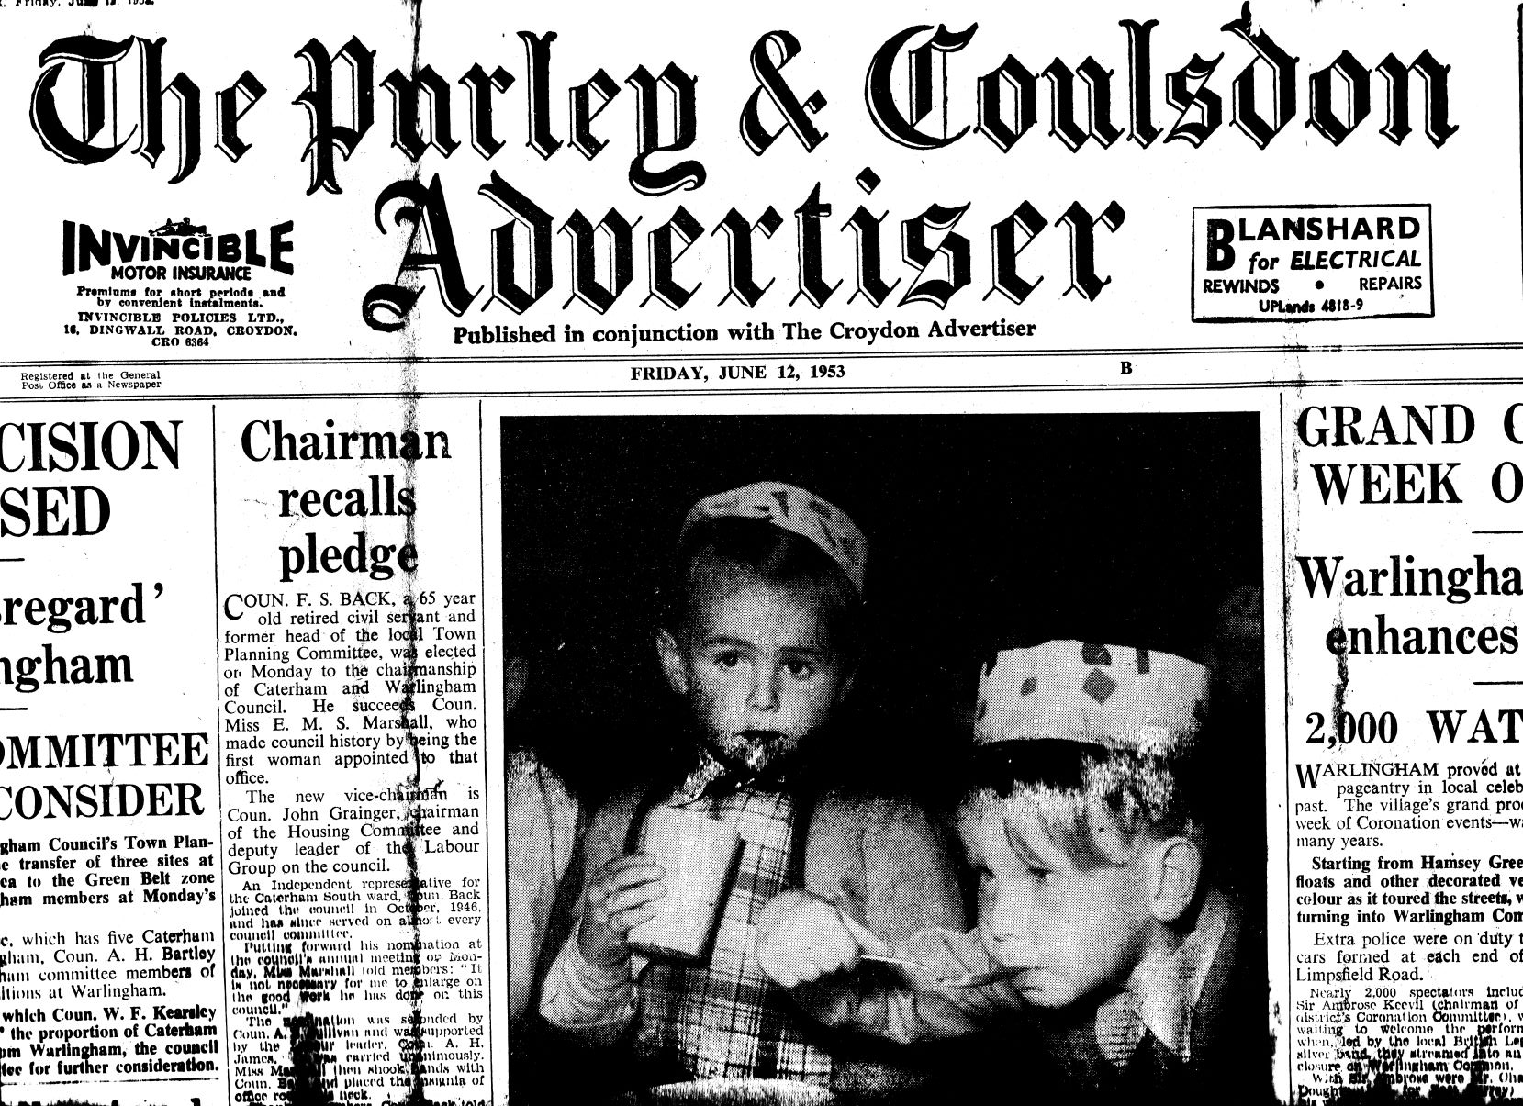

Primary School seemed to go by in a flash with mainly happy memories. One of the first memories however was a rather painful one. Jumping over skipping ropes was a popular activity at break time, but in the summer of 1954 some 'rather mean' girls pulled the rope taut just as I was jumping over - the result, a broken leg which kept me in plaster for the rest of the summer, including our annual holiday to Broadstairs, which remained our holiday destination for the next eight or nine years. For me, one good thing came out of it - from then on I went home at lunchtime which was made even more pleasurable since it led to my first paid job!

Nobby Clark, the Express Dairy milkman would come into Ingham Road at exactly the same time as I did at lunchtime. I loved horses and it didn't take me long to make myself indispensable in the deliveries to the road and the close. Duties included loading crates, delivering special orders, holding on to Emily the horse, and later Duchess after Emily broke a leg when falling in icy conditions one winter. I was particularly valuable for delivering to the 'posh houses' up the hill because it was too steep for the horses! One perk to all this was a ride on the float (no health or safety then) and of course my 'pay' - a small bottle of orange the same size as the bottles of milk that all primary kids got at breaktime - until Thatcher, the milk snatcher, stopped it as Education Secretary in the 1970s!

Education at Selsdon Primary continued with Mrs. Moir, in a classroom above the terraced flower beds which the senior pupils used to tend with mixed results, and then to the lower main building with Mrs. Sully, who was a bit of a dragon, then Miss Williams(on?) who I fell in love with and who really inspired me to learn not least by encouraging us to read by reading stories - Arthur Ransome's Pigeon Post was a particular favourite. Finally, in our last year I was in Mr. Younghusband’s class - a kindly but firm teacher who was probably responsible for me passing the 11+ in 1959. Mr Younghusband also took us for football, a sport I came to love, in the main playground with two gates in railings at either end serving as goals for us to kick the tennis ball through - bigger balls were banned for fear of breaking the school hall windows! It was the precision needed to kick a small ball that I am sure gave all of us co-ordination skills. I went on to become the school football team's captain and later in life a player in a number of local teams.

The only other memory of note was getting into trouble for throwing stones at girls on the field behind the school and of being terrified by Miss Bjork the headmistress when on the carpet in her office. I did also get interested in music - not particularly from the lessons of music and movement (pretend to be a tree and freeze!) - but from singing and the obligatory Christmas concerts and Nativity plays. With my parents’ interest and encouragement I learned to play the violin from age 7.

I made many friends including Geoffrey Featherstone, my best pal till he moved to Hong Kong, John Brumell, John Wooton, Simon Noakes, Andrew Wood, the twins John and David White, Andrew Woods, Nicholas Holt, Michael Sycamore and the odd girl or two including Jill Percival, Sally Hughes and Lorna Chessum.

***Phil Munton***

***Editor’s Note*** *- Mr Younghusband was still there in 1975 when I started as a teacher at the school - deputy headteacher at that time. It is interesting how significant the milkman (and his horse, Emily) was in many lives. They have been mentioned by Des several times and figured in a letter from David Owen in last month’s Gazette.*

**~~**

**ROUNDABOUT**

**In common (hopefully) with every other Selsdon household,** a copy of the *Good Neighbour Guide* recently fluttered through my letterbox. Produced by the Croydon Borough Neighbourhood Watch Association, it is cogent and well-presented. It cites a stream of common nuisances which plague us all, ranging from fly-tipping to indiscriminate parking. The booklet lists a comprehensive range of useful contact telephone numbers, helpful if one wishes to report matters of concern or crime.

As exampled by the recent reminiscences in the Gazette, Selsdon has always prided itself in being a supportive community. (Although possibly today most of us are preoccupied with our smart phones and computers!)

Should you not have yet perused this useful booklet, please avail yourself of the next opportunity. Thanks are due to our local councillors, Helen Pollard and Robert Ward, for their support of this valuable project.

**Sellis observes** that Selsdon may be invaded by large numbers of London Cockneys. I enquire as to his reasoning for that assertion as Selsdon is some distance from Bow Bells. Sellis draws to my attention the planning application for a Pie, Mash and Eel Restaurant in Selsdon.

Sellis recalls his relatives who used to live in Bethnal Green when the Mile End Road was awash with such restaurants as the menu was a staple food for most residents. Since those days, the London Cockneys have moved out to Essex and Epping Forest.

I suggest that Sellis may wish to cultivate his Cockney accent. “Not ‘arf” responds Sellis. I suggest that he sounds more like Dick Van Dyke in *Maree Pappins* than the more authentic Michael Caine in *Alfie.* I recall that some years ago a stall in Surrey Street also offered the same bill of fare.

As I totter upstairs to bed, Sellis calls out. “Mind how you go up the apples and pears - just in case you fall and become brown bread!”

Insufferable man.

***Carousel***

**~~**

**SHIRLEY WINDMILL - OPEN DAYS**

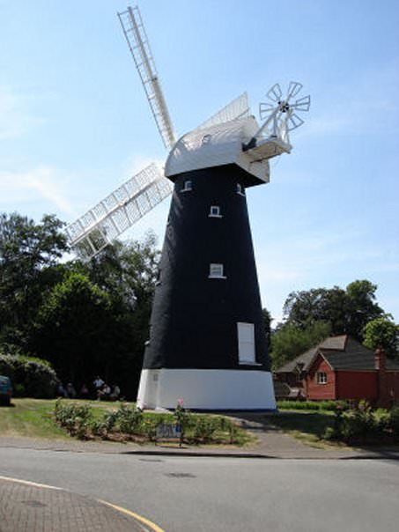OK, so not a Selsdon based activity or institution, but then how many windmills are there within 3 miles of Selsdon and only 7 minutes away by car? And there is a tenuous Selsdon link. *

The Friends of Shirley Windmill (shirleywindmill.org.uk) have announced their open days for 2019:

From 12 noon to 5pm the Friends are offering free guided tours of the mill on the following dates: 12th May, 2nd June, 7th July, 4th August, 1st and 22nd September and 6th October.

Tours last approximately one hour and will deal with the history, operation and features of the mill. A William Alwen is credited with having the first Post Mill built in 1808 and he and his son, Richard Alwen, ran the mill until his death in 1850. Grandson Richard then milled until a fire in 1854 destroyed the mill. He had the mill rebuilt as we see it today. Skipping forward, the mill was listed in 1951 and subsequently incorporated within the grounds of John Ruskin School. In 1990 the school was demolished and Croydon Council sold land to a developer, which resulted in Postmill Close (just off Upper Shirley Road, CR0 5DY) and the houses which now surround the mill.

Parking is available locally but buses 130 and 466 have stops nearby while buses 119, 194 and 198 stop near the Wickham Road roundabout. Do check out the Friends of Shirley Mill website for more details.

* The Alwens are buried in St Marys Church, Addington, so strictly speaking ,can be found in Selsdon, within the ward boundary of Selsdon and Addington Village.

***Ian Leggatt***

**Please include photo if space allows.**

**~~**

**WHAT A DIFFERENCE A DAY MAKES!!**

As we all know, we can never predict what a day may bring, we only know what we have perhaps scribbled into a diary, but a day is worth so much more in surprises. Take yesterday for example. It was just a normal day going through the normal chores, cleaning, ironing, having a walk, watering plants, cooking dinner etc. ... and then I turned on my e-mail ...... and the day was a very extraordinary day indeed.

At first all I saw were the endless dreary ads and as I sighed my way down the list, deleting as I went, I almost deleted an e-mail from one daughter, which brought me back to attention pretty smartly, and then one from my brother and one from a cousin and finally there was one from my cousin’s wife. It felt like Christmas to hear from so many close people and all at once, what on Earth was going on? There was even something from a woman whom I had never heard of.

Going back down the list I started with daughter and all was well, phew! Then I tried brother and wham it had become a bright sparkling day. My sister-in-law had been short  listed for a writing prize. Although we had seen her on TV at times she had never done something as amazing as this before. We were so excited for her. The day couldn’t get any better than that surely? Oh but when things go well it can all come at once in a lovely way too. Just the reverse of bad times when the news goes from bad to worse.

My cousin’s wife’s a keen ancestor tracer and she had not only discovered a family tree which entwines with ours, but the woman whom I had never heard of was the person who had got in touch to tell us all about herself and her father and grandfather.

Our grandfathers had fallen out and had ceased speaking, but I had known they made up before my grandfather died and was one of the party who went to get the two elderly gents together. The others had been unaware until my cousin’s wife remembered something I had said and took her researching from there - and found the missing relatives! More importantly the woman was delighted to find she had hidden relatives and had written an e-mail telling us all about herself and saying she hoped perhaps we may meet.

Turns out we have a lot of traits and skills in common. At a time when the relatives are beginning to thin in number it is a blessing to find a welter of new ones.

If anyone reading this is considering doing some ancestor tracing of their own, you too may find a long lost relative or two. Well worth doing if you feel lonely, or just want an interesting job when sitting down.

What a difference a day makes.

***Jessica Blake***

**~~**

**LETTER FROM FLORIDA - PART 2**

Last month, I introduced you to Hernando County, near the Gulf Coast of Central Florida, with its miles of inland waterways teeming with wildlife. One special form of wildlife is the manatee, a gentle giant of the seas and the rivers where they congregate in the winter months. Vegetarian to a ‘V’, they were once endangered, bumped and injured by speeding boats, but their protection is now guaranteed and their chances of survival greatly improved.

It has been said that manatees reminded sailors of mermaids. I have never understood this. Everyone knows that mermaids are beautiful sea creatures with flowing hair, fish tails, and a lot more besides. No way do they resemble manatees, and any sailor suggesting otherwise should be hauled off the ship and despatched to that well-known high street chain of opticians.

 

Weeki Wachee mermaid Manatee

What you may not know is that since 1947 mermaids have performed daily for visitors in the Weeki Wachee Springs State Park. They act, sing, laugh and perform graceful ballet routines deep under the spring water, in front of a rapt audience in a theatre on the other side of a glass viewing area under the deep spring, where fish and the occasional visiting turtle pass by. It’s just magical, and an ‘Old Florida’ attraction long before Disney came to Orlando (and a great deal cheaper!). The story of the Little Mermaid is their speciality. Children love it and it’s impossible not to be moved by their grace and their skill at holding their breath under water, miming to songs and dialogue, and even eating apples and bananas or drinking bottles of coca cola. Oh yes, and they do look very good!

When you have finished marvelling at the mermaids, you can step across to the river and take a canoe down the five miles of crystal clear Weeki Wachee River to the sea. Manatees can be seen in the winter months and plenty of other wildlife besides, but it’s very rare, you’ll be glad to know, to spot an alligator.

Now for a piece of pure nostalgia from the late 60’s. Do you remember the Byrds and the song Mr Tambourine Man, a No 1 hit in 1965? They were touted as America’s answer to the Beatles, all long hair and funny glasses. In fact, they were much better, sang complex harmonies, and played 12-string jingle-jangle guitars, but that’s another story.

While we were staying near Weeki Wachee Springs last November, two of the founder-members of the Byrds, now in their 70’s, Roger McGuinn (who played a solo gig at the Fairfield Hall a few years ago) and Chris Hillman, were due to perform in concert at Clearwater to mark the 50th anniversary of their ground-breaking country music album Sweetheart of the Rodeo. Seats weren’t cheap and I hesitated. But I reflected that we were unlikely ever to see them perform together again. We weren’t disappointed - it was magic!

***Bill Gale***

**Please include photos with captions if space allows.**

**~~**

**Please insert here full page Contact article supplied as “May 2019 - Form filling.”**

**~~**

**NATURE NOTES**

**HAIRSTREAK BUTTERFLIES**

The Hairstreaks get their name from the thin streak on the underside of the wings, more visible in some species than in others but a characteristic of the group.

**Green Hairstreak** - This is an early season species as it can appear from the middle of April but there will still be adults around at the end of June. Though the upper surfaces of the wings are a dull brown they are seldom noticed as the butterfly perches on bushes with the distinctive brilliant green undersides visible. The insect maintains a territory and will frequently return to the same perch. Colonies are usually small but I have seen what appeared to be hundreds flitting over the tops of Bilberry in Derbyshire. Apart from Bilberry they will lay eggs on Gorse, Bramble and several other plants.

**Purple Hairstreak** - This is a very common butterfly, from mid-July to late August, but easy to miss as it spends most of its time wandering over the leaves of Oak trees. As they fly from one branch to another, usually in the early to late evening when they are more active, light reflecting from the pale underwings makes them more visible. They settle with open wings so that the purple sheen on the upper surface is quite visible.

**White Letter Hairstreak** - The name of this species comes from the shape of the hairstreak which forms a distinctive letter W. The butterflies are on the wing from late June through July but, as the species relies on Elm trees, its numbers can be decidedly local. Prof Jeremy Thomas recounts watching a group from ground level and estimating about two dozen insects flying around at the top of an Oak where they were presumably feeding on aphid honeydew, but on climbing a nearby tree to get a better view he found the number was nearer to 70 butterflies. I have watched a dozen or so butterflies feeding on Goldenrod at High Elms in Bromley, and several individuals on other plants in various places.

**Brown Hairstreak -** Adults of this species can be found from late June to early September but sightings are not common as the insects spend most of their time at the tops of trees. They use master trees, Ash or other trees which are locally higher than neighbours, as a meeting place for males and females, but the females then fly off, possibly some distance away, to lay their eggs on Blackthorn bushes. Finding and counting the eggs in winter when the bushes are bare of leaves can show that the butterfly is surprisingly common in some areas despite the relative lack of sightings of the adults. A butterfly seen well will most likely be a female which has a rich brown colouring on the upper wings supplemented with a pair of bright orange patches.

**Black Hairstreak** - This is the rarest of the hairstreaks as it is confined to an area near Oxford. Flight period is short, perhaps the last week in June and first week in July. The butterfly can easily be mistaken for White Letter Hairstreak but spends most of its day seeking honeydew at the tops of trees, though they will also take nectar on Privet flowers. Eggs are usually laid on Blackthorn and, like those of the Brown Hairstreak, remain there throughout the winter.

For more information on these and all other British butterflies read the fascinating book by Prof Jeremy Thomas – Butterflies of Britain and Ireland.

***Ted Forsyth***

**~~**

**LOCAL CHOIR TRIUMPHS AGAIN**

Award-winning Soul Symphony Choir, your local community choir directed by Joanne Miller, wins again! The Choir participated in Croydon Performing Arts Festival 2019 and won the Gospel category. Jeffrey Davies, adjudicator for the Choral Section said, “Ladies and gentlemen in orange, what a wonderful concert this was, it really was. This was a really impressive example of gospel feel... It had that emotional impact the whole way through. Asante Sana – lovely African opening. Super communicative faces were as I expected and your movement was just enough to let the song do the work. Holy is the Lord – fantastic soloist, Theresa. The gospel feel was authentic throughout.”

Soul Symphony Choir is one of the most exciting vocal ensembles in Croydon and its surrounding London boroughs. Come along to a Tuesday session and consider becoming a member. 7:15pm at Emmanuel Centre, Rockhampton Road, South Croydon, CR2 7AQ. Allow yourself to be energised by the uplifting sessions and mutual support from this choir community.

Soul Symphony Choir will host their spectacular annual Summer Choir Festival. Proceeds from the ticket sales will be donated to charity, so please support us. This Festival promises to be a magnificent show. **Saturday 20 July, 6.30pm** at Normanton Road, South Croydon CR2 7AF.

***Joanne Miller***

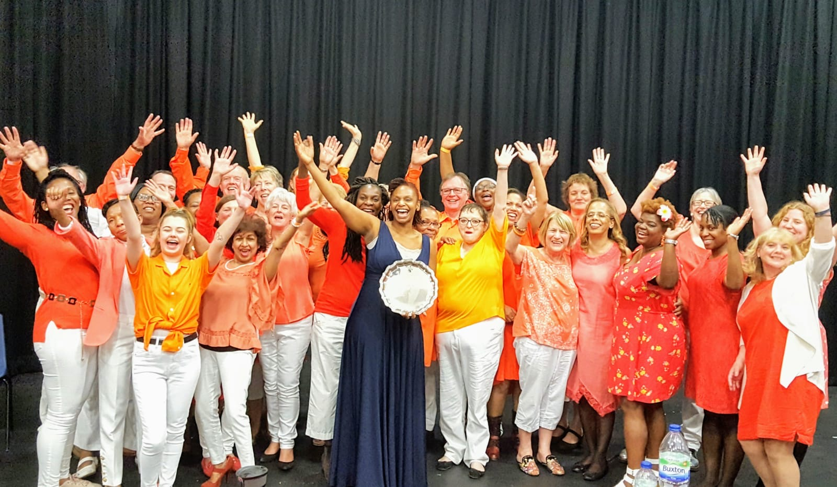

**Please include photo if space allows** - also supplied as file Soul Symphony Choir wins at CPAF 2019

**~~**

**WHAT’S ON**

**You will find here information of events that are taking place in our area that may not have been mentioned elsewhere in the Gazette.**

**~~**

**CROYDON BOWLING  AND SPORTS CLUB**

will be holding an OPEN DAY on 23rd June 2019 10.00 -  16.00

Why not try our facilities for FREE!!!  We have 6 indoor and 12 outdoor rinks and welcome new and experienced bowlers. You can also see our other facilities, including bridge, croquet and snooker. You can join our fantastic Social Club. We hold regular events, quizzes, dances, parties, cabarets and theatre trips. If you are coming along please try to bring a pair of flat soled shoes (no heel) but no worries, if you have not got your own we do have some you can use. All other equipment will be supplied on the day.

Membership is FREE for two months to new members on our OPEN DAY, plus we offer generous student rates. A warm welcome to all at any time.

For further information contact Alan 0777 2022 156 to make an appointment, or email [alan9483@aol.com](mailto:alan9483@aol.com)

The address of the club is 10 Nottingham Road, South Croydon CR26LN

**~~**

**CROYDON AND DISTRICT PARKINSON'S GROUP** runs seated/standing/supported exercise classes at Purley URC Hall (next to Purley Hospital) 1 -2 p.m. every Monday, and a new class has just started on alternate Thursdays at St. Mildred's Church Hall close to Addiscombe Tramlink, 12.45 - 2.15 p.m. The Group also holds monthly social meetings at the Purley location, usually on the third Monday of the month 2 - 4 p.m.

Don't suffer Parkinson's on your own, come and join those who understand the problems it causes and find out about all the services and help available, both locally and nationally.

Contact our Secretary, Jacky Green, on 01737 355487 or email [jackygreen234@hotmail.com](mailto:jackygreen234@hotmail.com) for further details.

**~~**

**THE RSPB CROYDON LOCAL GROUP**

**Monthly Illustrated Wildlife Talks in South Croydon**

Whitgift Sports Club, Croham Manor Road - off Croham Road. South Croydon, CR2 7BG. Second Monday of each month, 2pm and again at 8pm. Admission £4. Everyone is welcome, not just RSPB members. Free refreshments. A selection of RSPB goods, nuts & seeds are on sale. Parking limited on site but free in adjacent roads. 64 & 433 buses stop nearby in Croham Road.

**Monday July 8th 2019: “W H Hudson – an RSPB Legacy”**

Author and conservationist **Conor Mark Jameson** explores how this impoverished immigrant from South America rose to prominence in Victorian and Edwardian Britain, what his contribution was in the early stirrings of conservation activism in the UK, his place in literature, and how his legacy can still be felt today.

For more information contact John Davis on 020-8640 4578 or see [www.rspb.org.uk/groups/croydon](http://www.rspb.org.uk/groups/croydon)

***Note: on request we give illustrated bird talks to local organisations.***

**~~**

**FRIENDS OF SELSDON WOOD**

Do join us for our lepidoptera & bat walks in July:

**Saturday 13th July @ 11am ‘Butterflies’ with the Friends  
Thursday 18th July @ 9.00pm ‘Bats & Moths’ the Friends**

*Meet in Selsdon Wood car park, Old Farleigh Road.*

*To make enquiries or to check the above, see the Walks and Workday pages of the website*[*www.friendsofselsdonwood.co.uk*](http://www.friendsofselsdonwood.co.uk/)

*Or phone 020-8657 0423 or e-mail:*[*selsdonwood@gmail.com*](mailto:selsdonwood@gmail.com)

Selsdon Wood is owned by the National Trust and we have our own page on their website at <http://www.nationaltrust.org.uk/features/selsdon-wood>

**~~**

**THE SELSDON CENTRE FOR THE RETIRED**

Find us inside the Sainsbury’s building in Selsdon, Surrey

We are open five days a week from 10:00 – 15:00, serving hot lunches for retired local residents.

As well as providing a place for the elderly to meet, we have numerous other activities going on including

**1-2-1 computer training on laptops, iPads and tablets**

Our I.T. expert is available to give lessons in a quiet room in the Selsdon Centre on Friday mornings, if booked in advance.

It is possible to book an individual hour long lesson or a block of 5 sessions, at very competitive prices!

So, if you are interested in brushing up your IT skills or would like a complete beginners’ lesson, please do give us a call, email or pop in for more information.

**We look forward to welcoming you at the Centre soon!**

Tel: 0208 651 1111 Email: selsdon.centre@btinternet.com

[www.selsdon.centre@btinternet.com](http://www.selsdon.centre@btinternet.com)

**~~**

**ART CLASSES** run at the Shirley Methodist Church on Tuesdays and Thursdays.  
We start back next term on **May 7th and 9th** and run for ten sessions .  
On Tuesdays it’s Drawing and Painting starting at 10.00am to 12.30pm and after lunch from 2.00pm to 4.30pm. On Thursdays it's Life Drawing, from 10.00am to 12.30pm and then after lunch, 1.30pm to 4.00pm, it's Portrait Drawing.

For further information contact Stewart Ganley on [vangan4669@gmail.com](mailto:vangan4669@gmail.com) or mobile 07745586807.

**~~**

**‘HOLIDAY at HOME’ AT SELSDON BAPTIST CHURCH**

Once again Selsdon Baptist Church is hosting a ‘Holiday at Home’ for Selsdon Seniors. This year our theme is ‘Wonderful Wales’ and it will be held at the Church and in the Halls from Monday 29th July, on alternate days, through to Sunday 4th August.

Many Selsdon Seniors have attended over past years and it is ideal for those who cannot get away on a proper holiday. Come and enjoy being waited for morning coffee, lunch and afternoon tea. There is also the opportunity if you wish, to be active with quizzes, crafts and puzzles or maybe you would prefer to simply relax.

Music will also feature in our programme this year

If you would like to attend or would like to know more, please contact the Church Office on 020 8651 4308 to apply for a booking form. Places are limited so do not delay!

We hope to see you there

The H@H Team at Selsdon Baptist Church

**~~**

**SELSDON PRIMARY SCHOOL WARTIME REUNION – 2019 DATE CHANGE.**

Please note that this popular event will now be held at the Farleigh Golf Club on **Wednesday 16th October 2019.**  Details will follow in due course.

**~~**

**COMPANY CLUB** welcomes lively over 45's to social events including theatre ,cinema, meals out, quizzes, barbeques, walks etc. New members evening - 1st Thursday of the month. Contact Linda [020 8668 1382](tel:020%208668%201382), Glenn [020 8656 9007](tel:020%20656%209007), Shirley [020 8651 5835](tel:020%208651%205835). [www.companyclub.co.uk](http://www.companyclub.co.uk/)

**~~**

**SELSDON CENTRE BOOK CLUB**

If you like reading, and discussing what you have read, why not come along to our book club?  We are a small group and members suggest a 'book of the month' (from classics to contemporary, plays to poetry) which we discuss,  
followed by tea/coffee and biscuits.

We meet on the third Thursday of the month in the Selsdon Centre at 2.45 pm, and there is free parking in Sainsbury's car park. New members are always welcome. The cost is £3.50 for each session or by subscription.

Forthcoming meetings are on **May 16, June 20, July 18, August 15, September 19, October 17, November 21** (None in December)

If you would like to know more please contact Maureen on 020 8651 2336 or. email [stagg435@btinternet.com](mailto:stagg435@btinternet.com)

**SANDERSTEAD LOCAL HISTORY GROUP**

SLHG  meetings All Saints Church hall at 2pm. The hall is on bus routes and there is a free car park. Small fee of £2 each visit to cover hall and refreshments - no annual fee. All welcome

**April 24 - Shirley Windmill and the Alwen Family** - Chris Harman

**May 29  - Barlow Trecothick, builder of Addington 'Palace'** - Joyce Hoad

**June  26 - Secrets of the Bayeux Tapestry** - Phil Revnell

**July 31 - Roman Road - discovering the route from Farleigh to Beckenham** - Frank Mercer

Contact Joyce Hoad (Chair) [joycehoad@virginmedia.com](mailto:joycehoad@virginmedia.com)

or [chris.harman@tiscali.co.uk](mailto:chris.harman@tiscali.co.uk)

**~~**

**SELSDON FLOWER CLUB**

We are a small friendly club who meet on certain Wednesday afternoons at 2pm at the rear of St. John the Divine Church, Selsdon. Subscription £25 per annum. We have demonstrations, workshops and practices.

24  April           Workshop - Eve Johnson

8 May               Demo - Sue Tausig

22 May             Practice - Tall and Elegant

12 June            Practice - Summer in Bloom

**Please contact the Secretary, Maureen Browning on 020 8651 5821 for more details**

**THE ARTS SOCIETY SANDERSTEAD**

**Tuesday 28th May 2019, 10.30 - 11.45am**- Sanderstead United Reform Church Hall, Sanderstead Hill, CR2 0HB (next to Sanderstead Library, parking in surrounding roads, 403 Bus Route)

**"Leslie Primo" - Angelica Kaufmann: an Artist in 18th Century England"**

Leslie Primo holds a BA in Art History and an MA in Renaissance Studies from Birkbeck College, University of London.  He gives lectures and guided tours, plus special talks at both the National and the National Portrait Galleries.  Leslie also lectures at the City Literary Institute and has presented a series of talks at the National Maritime Museum and the Courtauld Institute.

Coffee is served from 9.30am - 10.15am.  Please register when you arrive.  There will be a small fee of £5.

For more information on joining our society so that you can take full advantage of our wider programme of day visits, foreign/home tours, Special Interest Days, Annual Lunch and other social events, please ask for details at the hall or ring

**Sue Davenport** 020 8660 9122 **Website:**[www.theartssocietysanderstead.org.uk](http://www.theartssocietysanderstead.org.uk)

**~~**

**MUSIC EVENTS FROM THE PHOENIX COLLECTIVE – SAVE THE DATES!**

* Do you write songs? Are you a singer or choir leader who would like some help arranging a piece to sing? If so, put this date in your diary! The Selsdon-based Phoenix Collective are excited to announce a visit by American a cappella expert Chris Rupp (founder of the NBC Sing-Off winners, Home Free), on Sunday 19th October 2019. Chris will work with individuals or groups on aspects of song-writing and a cappella arranging.
* Are you a primary class teacher wanting to learn how to teach music? Are you a primary music specialist looking to refresh your practice with new ideas and insights? If so, come to the ‘Music in the Primary Classroom’ course on 26th-27th October 2019! This is hosted by Selsdon Resident Cyrilla Rowsell (author of the Jolly Music series) and Gerard Klaassens, a creative music educator from The Netherlands.

More details to follow but SAVE THE DATES NOW! [www.thephoenixcollective.co.uk](http://www.thephoenixcollective.co.uk)

**~~**



*We welcome your letters so do please get in touch if you have something to share with Selsdon residents.*

*Please remember to state your name, address, contact number, and publication anonymity requirements in* ***all*** *correspondence to the Editor. Anonymity can be granted on request, but anonymously sent letters/e-mails will not be published.*

***Heather Govier, Editor***

**~~**

**27 March**

By now, I expect you have received several responses to your February 6th letter asking for more information about A D Sanderson’s ownership of a 1934 Rolls Royce.

I believe the answer will be found in the quotes below, concerning **Allan Doble Sanderson** - a businessman, inventive engineer, motor-racing driver and automotive enthusiast who parlayed his commercial successes to create Selsdon Park Hotel circa 1928.

I worked at the hotel in 1951 and frequently saw Mr. S. driving his early Jaguar XK120 around the property; it was on those rare occasions that he smiled. However, I regret that I never saw the 1934 Rolls-Royce. (See below for photos of both vehicles.)

***Michael Fox - Selsdon resident 1937-1953***

*“Allan Doble Sanderson was a prominent businessman who owned the firm of London Lubricants which he sold in 1927, following the acquisition of Selsdon Park. He was also a motor-racing driver who competed at the famous circuit, Brooklands, and at racing venues on the Continent between 1920 and 1924.”*

*“Allan Sanderson decided to pursue a new business career and in 1924 he embarked on an exciting, innovative commercial venture by purchasing Selsdon House and its estate grounds. His idea was to convert the 23-bedroomed Victorian country residence into an illustrious hotel. For this purpose he employed the architect Hugh Mackintosh, who spectacularly enlarged the building in 3 stages.”*

*“Mr Basil Sanderson, son of Allan Doble Sanderson … took over control from his father in 1960 and … developed Selsdon Park into one of the finest hotels in Europe.”*



***Editor’s Note –*** *The quotes come from a 16 page booklet, “Selsdon Park - The History” published by Basil A Sanderson in 1985. The full booklet is available on the SRA website History of Selsdon page* [*https://selsdon-residents.co.uk/history-of-selsdon.php*](https://selsdon-residents.co.uk/history-of-selsdon.php)*. The Principal Hotel Company, who bought the property from Basil Sanderson in 1997, recently refurbished it and adopted the new name, the De Vere Selsdon Estate.*

*See the website*[*http://www.realcar.co.uk/view-cars/2323*](http://www.realcar.co.uk/view-cars/2323) *for more information about the Rolls and about A D Sanderson - clearly he was a bit of a lad!!!*

*See also the letter below offering another online source of information.*

**~~**

**14 April**

Hi Heather,

The Sanderson family had the hotel until 1997. Potted history available from the following link: <http://www.londongardensonline.org.uk/gardens-online-record.php?ID=CRO075>

***Ian Leggatt***

**~~**

**16 April**

Hi Heather,

Reading last month’s edition I note that Frank Kippin wants to know the original owner of the Selsdon Park. When it was sold to De Vere it was owned by the Sanderson family, headed by Basil. I understand at the time it was the only 4-star hotel owned by individuals. The accountants I worked for helped with the sale. I checked Google and my memory of the name was right. I assume it was Basil in the picture with the dogs.

***Regards, Neil Taylor***

**~~**

**2nd May**

Dear Heather,

I received the April issue today and here I am again talking again about the owner of the former Selsdon Park Hotel, just a month after our previous correspondence.

Allan Sanderson opened the original hotel in 1925, oversaw the building of several extensions and managed the business until he handed the reins to his son, Basil, in 1960; as it remained the family business until 1997, I believe it's reasonable to  assume that the painting was of their two dogs. Dogs played a significant part in the Sandersons' lives as they also operated three greyhound tracks,  raced several dogs, and employed three greyhound kennel girls.

When I worked at the hotel in 1951/52 it was quite usual to see two large dogs meandering around the public areas (but never in in the restaurant), sometimes one would adopt an armchair. I couldn't identify the breed but they were not Labradors.

Unlike you, Heather, I can't remember noticing the painting because I was always too busy scurrying between the floors as a room service waiter. However I can corroborate your account of the dogs relaxing by the fireplace. If you are referring to events after 1960, it would indicate that the doggy tradition was maintained after Basil Sanderson took over from his father.

That's all I can offer on this subject

Sincerely,

***Michael 🦊***

***Editor’s Note*** *- I’m certainly talking post 1960 when they had the Labs by the fire and when I saw the painting. I did not move in to this area until 1975. In 1960 I was still wandering the hills of the Peak District!!!*

**~~**

Hi Heather,

Further to earlier correspondence (letter published in the May Gazette) I today received a letter explaining whilst my claim for damage to my cycle has been rejected

Apparently, a defect to the surface on the highway has to be at least 40mm deep. As you can imagine, 40mm to a cycle tyre can be catastrophic, my road cycle tyres are quite narrow of which 6mm is in contact to the road surface.

They also state in the letter that the defect had not been reported previously, whereas as we all know the state of this road has been subject to examination before.

To be honest, the claim I made, which was less than £30.00 is not important, but more as a principle.

My offer still stands, perhaps Mr Tony Marchant or Lyndon Jones (the people that dealt with my claim), would like to take up the challenge to cycle with me one morning along Farley Road.

***Terry Maher***

**~~**

**Please ensure that puzzle diagram and clues are on facing pages.**

**CRYPTIC CROSSWORD - JUNE 2019**

**Set by Oldie – Gazette Ref: 60**



**ACROSS**

7 Marriage guidance counsellor? He fixes things (8)

9 Game is ruined by prejudice (6)

10 Caught, getting time in prison (4)

11 Time invested in errant son failed – he has no chance of success (3-7)

12 Remember to visit again? (6)

14 Drug creating endless conflict at home (8)

15 Jack wants us back on road – ridiculous! (6)

16 Saucy. tasting of apple perhaps (6)

19 A struggle increased in Scottish town (8)

21 Note very little (6)

23 Nasty criminal upset Alan around start of November (10)

24 British agents keep hold of this tobacco (4)

25 Remove centre from pellets and grind – using this? (6)

26 Woman’s worked as model, having inclination (8)

**DOWN**

1 A teen’s represented in governing body (6)

2 Right away, plant evidence against celebrity (4)

3 Cambridge mathematician, one engaged in noisy dispute (8)

4 River subsequently needed for one travelling by water (6)

5 Changing to career in leisure activity (10)

6 Harshness, like compassion, the Queen embraced (8)

8 Owner adapts to new celebrity (6)

13 Uzis rattle violently in battle (10)

15 Lent progressed (8)

17 More will fail exam, being most aloof (8)

18 The woman’s lad upset the announcer (6)

20 Speaks of old values (6)

22 Communist art is brought back for businessman (6)

24 Fire gun, having no time to drive away (4)

There was no crossword in the May Gazette.