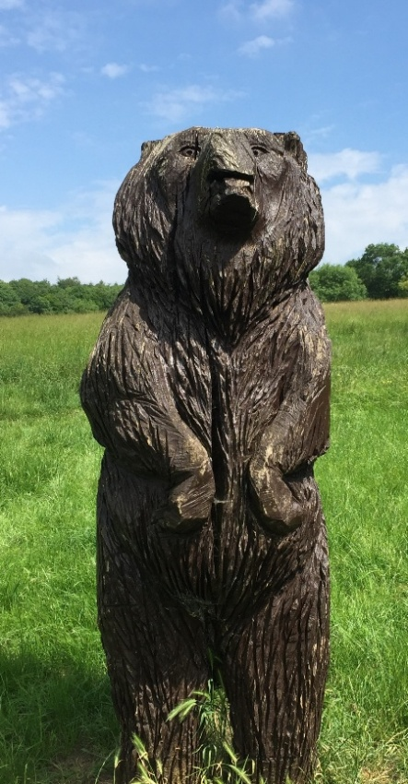 | FRIENDS of SELSDON WOOD (FSW)  Have you found the carvings in Selsdon Wood yet?  Come and join the guided walk  (for about an hour)around the trail  Meet at the Bear in the car park  at 13.15 on Sunday 7th September  Selsdon Community Event in Selsdon Wood, Old Farleigh Road
Information about the FSW projects can be seen on their stall at the event and on their website.
If you wish to support or take part in FSW work, do visit the stall to get more information or to make a donation
or enquire via selsdonwood@gmail.com or by text to 07979-002547

