Selsdon Residents’ Association
Children’s Egg Hunt Competition 2024
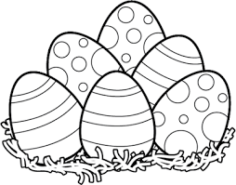
During the week from Thursday 28 March until Wednesday 3 April, six shops along our High Street will display a coloured egg in their shop window. All you have to do is to complete the form below with the correct location of each egg and your name, address and age*. Then get your parents/guardians to take a photo of the form and get them to send it by Friday 5 April to the Gazette Editor at selsdongazettesra@gmail.com
The winners will be drawn at random from all the correct forms received. (*Any data collected will be destroyed after the competition.)
Colour of Egg seen | Name of Shop where egg is displayed
Red
Orange
Yellow
Green
Blue
Purple

Name ___________________________________________________

Address _________________________________________________
_________________________________________________________
________________________________________________________
Age ______

