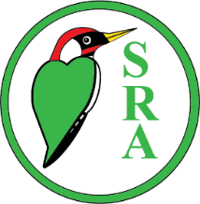**Selsdon Residents’ Association**

**CHILDREN’S EGG HUNT 2025**

During the week from Monday 14 until Monday 21 April, six shops along our High Street will display a coloured egg in their shop window. All you have to do, is to complete the form below with the correct location of each egg, together with your name, address and age*. Then get your parents/guardians to take a photo of the form and get them to send it by Wednesday 23 April to the Gazette Editor at [selsdongazettesra@gmail.com](mailto:selsdongazettesra@gmail.com)

The winners will be drawn at random from all the correct forms received.

(Any data will be destroyed after the competition.)

|  |  |
| --- | --- |
| **Colour of Egg Seen** | **Name of shop where egg is displayed** |
| **Red** |  |
| **Orange** |  |
| **Yellow** |  |
| **Green** |  |
| **Blue** |  |
| **Purple** |  |

Name ________________________________________________

Address ________________________________________________

_________________________________________________________

_________________________________________________________

Age __________