

Selsdon Residents’ Association

Gardening Competition 2026

An Upcycled Container Garden
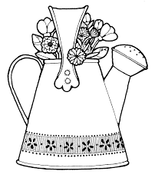

It is that time of the year when we launch the SRA Gardening Competition and this time it is open to everyone, even if you do not have a garden! As we are all being encouraged to recycle, this year we are asking you to use an object that you were thinking of throwing away to use as a container for your potted plant display.

To enter please send a photo of your upcycled container bursting with your floral display to the editor (selsdongazettesra@gamil.com) by the end of August. Make sure you include your name and address. This competition is open to all ages.

Start looking for an unusual, unwanted container and plan your planting scheme.

