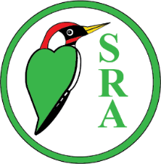

GAZETTE COVER COMPETITION TO CELEBRATE THE 100TH ANNIVERSARY OF THE SELSDON RESIDENTS’ ASSOCIATION
For all ages
Closing date for entries Saturday 13 December
In January 2026 the Selsdon Residents’ Association will be celebrating its 100th anniversary. There will be a special colour edition of the Selsdon Gazette and we are inviting you to design the cover. All you have to do is make an A4 sized drawing or painting depicting this special occasion. Put your name and address on the back and then pop it in any of the SRA committee members’ addresses listed on page 2 of the Gazette or via KIBA, 119 Addington Road.
Your artwork has to be your own work, nothing downloaded.
The orientation can be portrait or landscape but please remember to leave a space for the Selsdon Gazette title or have a full page design that would allow the title to be printed over it and not spoil your picture.
The winning entry will be used as the colour cover for the January Gazette.
Remember you’ve got to be in it, to win it!

