
Mini-Beast Hunt
with Roger Hawkins and the Friends
Wednesday 12th August @ 2pm
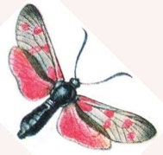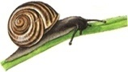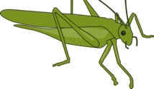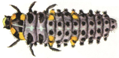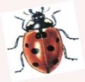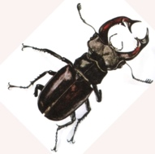
This event is great fun for accompanied children aged approx.5-11years
Come to have fun and learn all about minibeasts!
Meet in Selsdon Wood car park off Old Farleigh Road CR2 8QF

Participants are loaned collecting pots/nets.
They are taken on a walk to hunt
in the fields and hedgerows
for minibeasts of all shapes and sizes.
Then they show them to our team of experts
who will try to name each specimen.
Any queries: e-mail selsdonwood@gmail.com
or enquire via the secretary by text to 07979 002547‬.
See our website www.friendsofselsdonwood.co.uk and our Facebook page for our full programme and more information about our wood.

Why not use this event
(or just a walk in the wood)
to take photos of the mini beasts and the wood to enter the annual photo competition?
Each entrant can submit any number of photographs taken in Selsdon Wood between 20th August 2025 and 19th August 2026. The three most popular photos will be chosen by a secret ballot of the visitors to the SRA event
on 6th September.
There will be three cash prizes - £50, £20 and £10
Closing date - 20th August.
Send your entries to the above email address or to danceswithwolvezs@gmail.com

