
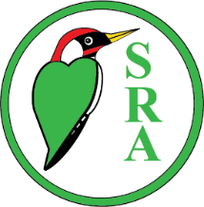
Selsdon Community Fair

Sunday 6 September 12 - 4pm

At the Old Farleigh Road entrance to Selsdon Wood

The SRA has organised the annual Selsdon Community Fair in Selsdon Wood. There will be the usual wide selection of stalls including crafts and foodstuffs, the Rotary have activities for children, the Scouts are providing the refreshments and ‘Songsations’ will be singing.

Put the date in your diary and we hope to see you there!



