Selsdon Residents Association
Grow the Tallest Sunflower Competition ‘24
Open to all residents of Selsdon,
especially those with green fingers!
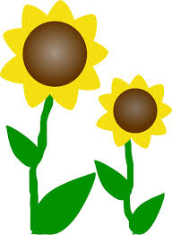
March is the month sunflower seeds can be grown indoors with May being the month to plant your seedlings outside in full sun. Flowers appear between July and September. Take a photo of your tallest sunflower, preferably with you alongside it. Measure its height from ground level to its tallest point and send the measurement and photo to the editor of the Gazette selsdongazettesra@gmail.com by the 20 September with the grower’s name and address. The tallest sunflowers will win the prizes.
.

